MicroGoals – Secure Goal Management Backend API
Team Info:
- Project Title: MicroGoals
- Team ID: SWTID-2026-5680
- Team leader:
-Sridevi A Mail id:sridevi008@gmail.com
- Team Members:
-Sridharshini.G Mail id:gsridharshenni07@gmail.com
-Srilekha R Mail id:srilekharajkumar175@gmail.com
-Sujitha R Mail id:Sujimaha1221@gmail.com

Project Overview
MicroGoals is a secure backend RESTful API developed using Node.js, Express.js, and MongoDB. It enables users to register, log in, and manage their personal goals through CRUD operations. The system uses JWT authentication and middleware to ensure data security and user-specific access control.
The system includes:
- User Registration & Login
- JWT-based Authentication
- CRUD Operations for Goals
- Protected Routes
- Centralized Error Handling
The main objective is to provide a secure and scalable backend system for digital goal management.

Project Instruction
- The project follows REST API principles.
- Authentication is handled using JWT.
- MongoDB is used as the database.
- APIs are tested using Thunder Client.
- The project follows MVC architecture.

Pre-requisites
Before running the project, the following tools are required:
- Node.js (v18 or higher)
- Express.js
- MongoDB (Local / Atlas)
- VS Code
- Thunder Client (Extension)
- Basic knowledge of JavaScript & REST APIs

Project Architecture Image (Text Representation)
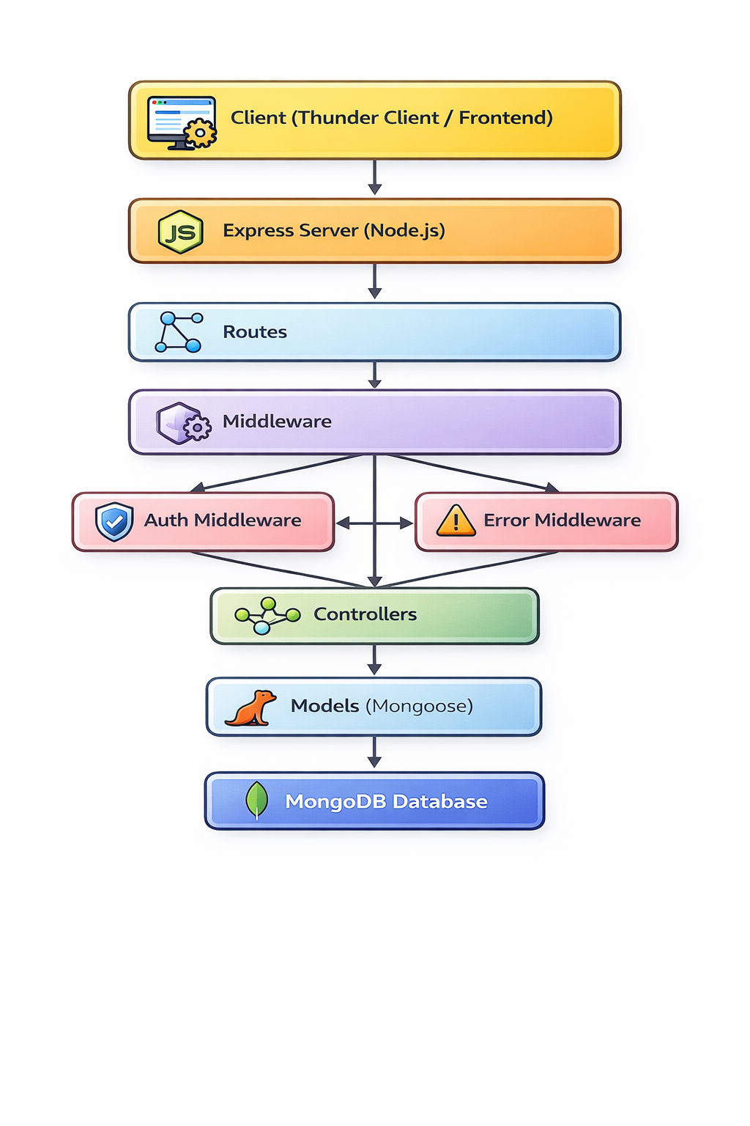

PROJECT ARCHITECTURE

TECHNICAL ARCHITECTURE
- Runtime: Node.js
- Framework: Express.js
- Database: MongoDB
- Authentication: JWT
- Architecture Pattern: MVC

ER DIAGRAM
Entities:
- User
  - _id
  - name
  - email
  - password
- Goal
  - _id
  - title
  - completed
  - userId (Reference to User)

Relationship:
One User → Many Goals
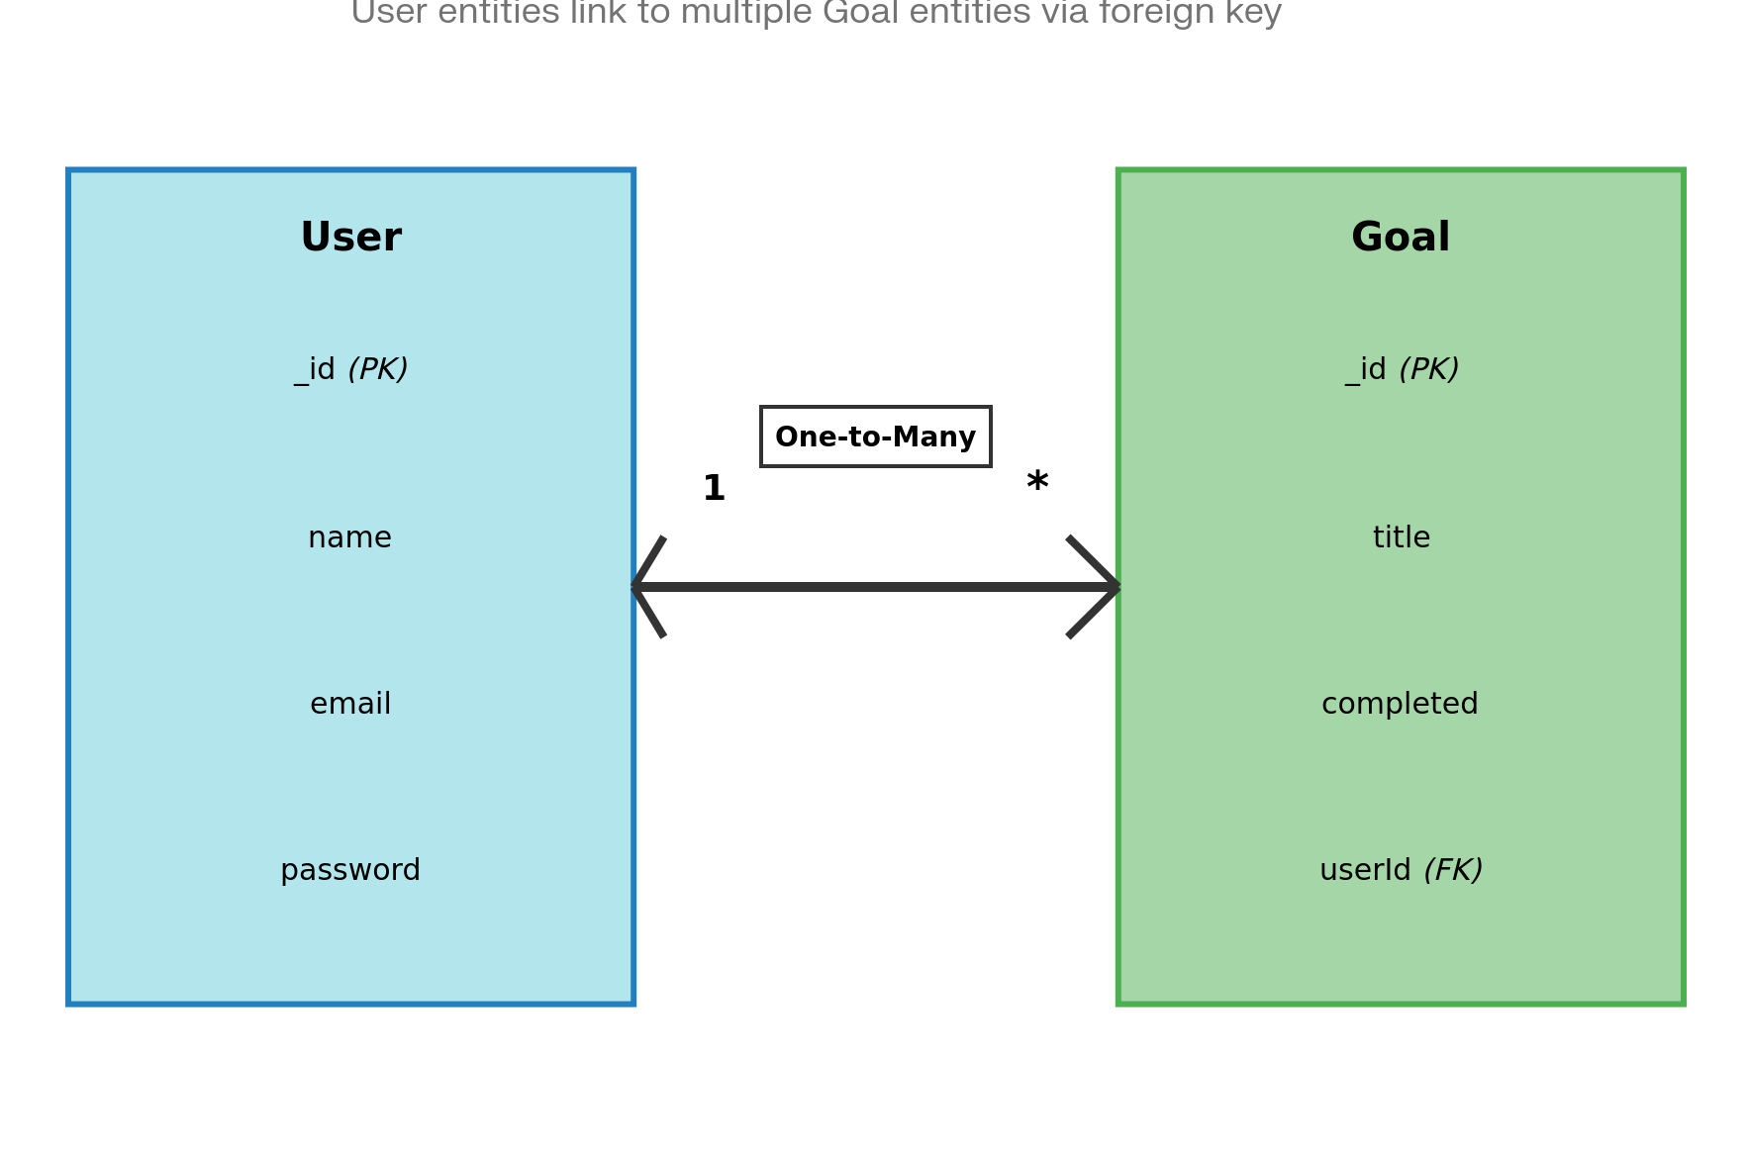

FEATURES
- User Registration
- Secure Login with JWT
- Create Goal
- Update Goal
- Delete Goal
- View User-specific Goals
- Protected Routes
- Centralized Error Handling

ROLES AND RESPONSIBILITIES
Role | Responsibility
User | Register, Login, Manage Goals
Developer | API Development & Testing

USERS FLOW
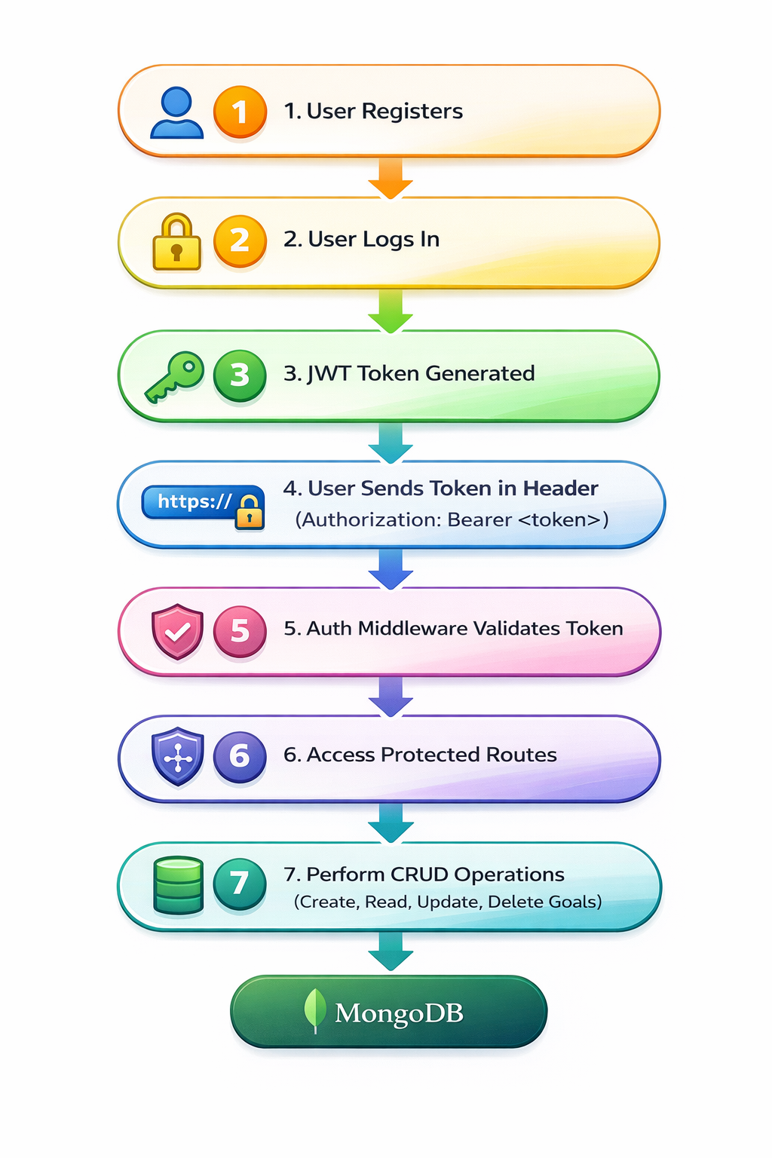

PROJECT SETUP AND CONFIGURATION

🔹 Folder Structure
MicroGoals/
├── middleware/
│ ├── authMiddleware.js
│ └── errorMiddleware.js
├──Schema/
├──User.js
├──GoalSchema.js
├── models/
│ ├── userModel.js
│ └── goalModel.js
│
├── routes/
│ ├── authRoutes.js
│ └── goalRoutes.js
│
├── .env
├── Index.js
└── package.json
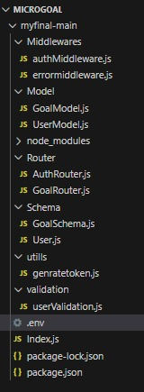

🔹 Project Setup
- cd <main folder name>(if required)
- npm install
- node Index.js (helps to check whether mongodb is connected)
npm install express mongoose jsonwebtoken bcryptjs dotenv
4.Start server:
node server.js

BACKEND DEVELOPMENT
- Created Express Server
An Express server was set up to handle API requests, connect routes, and enable JSON parsing for backend operations
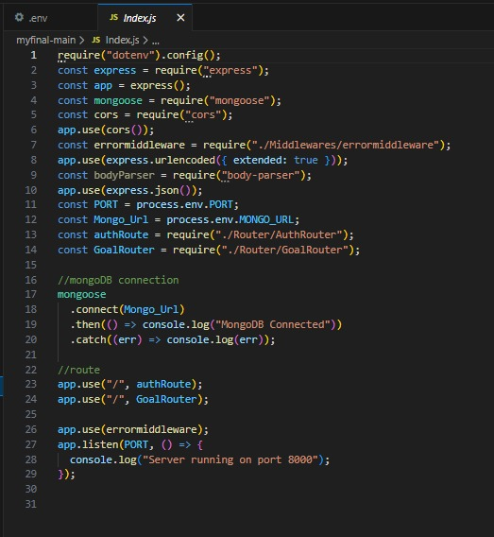
- Connected MongoDB

For Connection with MongoDB:-
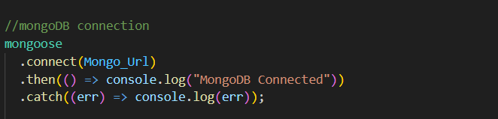
.env
The .env file is used to store sensitive configuration details such as the MongoDB connection string and JWT secret key. It helps keep important information secure and separates environment-specific settings from the main application code.

- Implemented Authentication APIs
User registration and login APIs were created with password hashing and JWT token generation for secure authentication
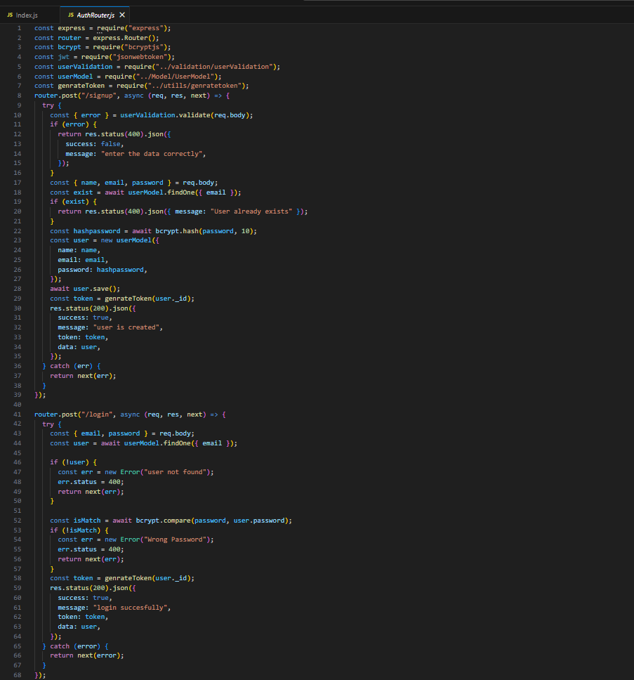

- Added Auth Middleware
- Auth middleware was implemented to verify JWT tokens and secure protected routes from unauthorized access.
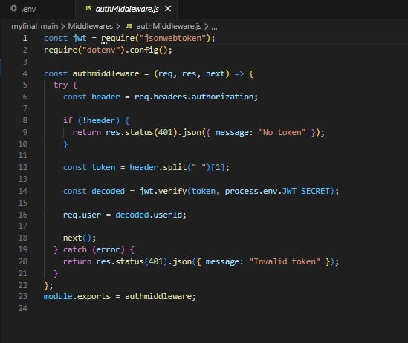

- Added Error Middleware
An error middleware was added to handle application errors centrally and return proper status codes and messages.

DATABASE DEVELOPMENT
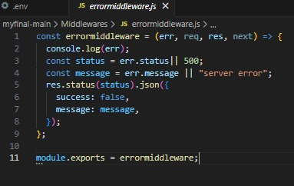

CONFIGURE MongoDB
- Use MongoDB Atlas or Local MongoDB
- Store connection string in .env
CREATE DATABASE CONNECTION
Index.js file:
- Use mongoose.connect()

- Handle connection error

PROJECT EXECUTION

Project Execution Steps
- Start MongoDB
- Run server
- Test APIs in Thunder Client
- Register User
- Login and get JWT
- Perform CRUD operations

Project Output Screenshots
- Successful User Registration (Signup/Login)
- In this Api call the user register or login and token was genrated
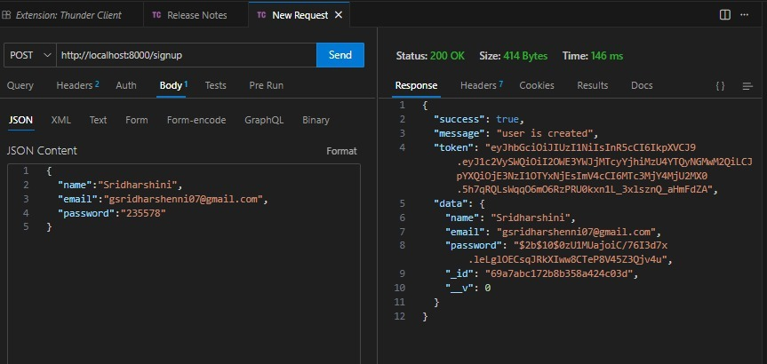
- JWT Token Response
After successful login user the api generate the token and these token was sent with every request to every api
- Goal Created Successfully
- After the login and token is generated the user give post request to api for creating there goals and goal was save in MongoDB which was the database
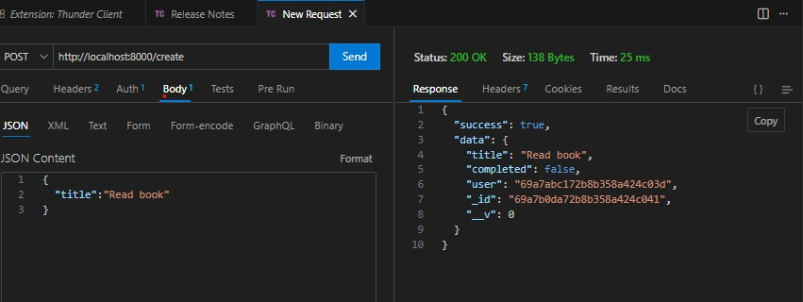
- Protected Route Working
- If the user does not have token which was generated by backend api then he cannot access the api so Route are protectedZ
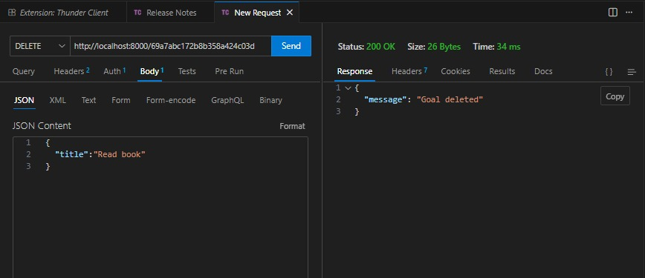
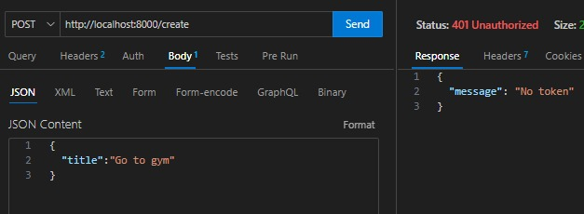
- After a successful login, the system verifies the user's email and password with the data stored in the database. If the credentials are correct, the server returns a response containing a success message and an authentication token that will be used to access protected routes. 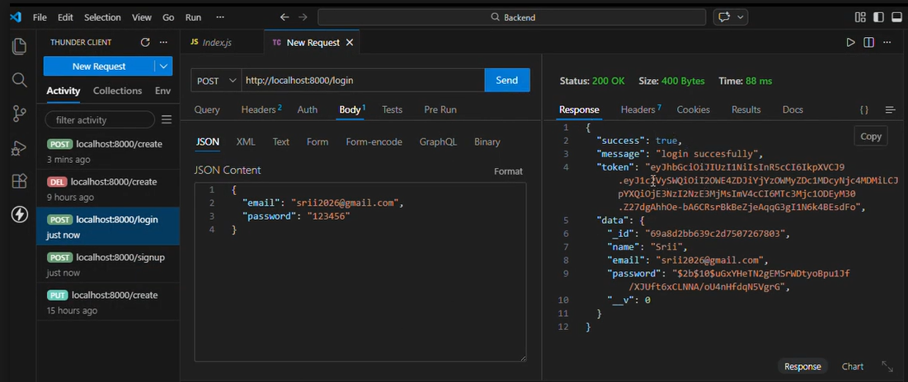

After updating a goal, the system modifies the selected goal’s details in the database based on the provided information. If the update is successful, the server returns a response confirming that the goal has been updated

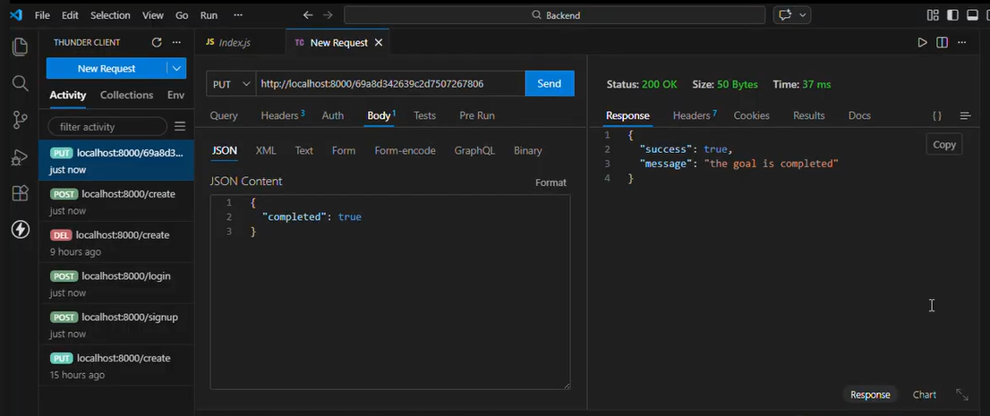

Project Demo Video
Record video showing:
- Registration
- Login
- Token usage
- CRUD operations
- Error handling
video: https://drive.google.com/file/d/1Us8iO2UXFeXKUZke8BIEOUS7es4Uk8Yl/view?usp=sharing
Drive: https://drive.google.com/drive/folders/1BWObjKBVgUydsRt_7NboWZH2UwgRhCE4?usp=sharing

